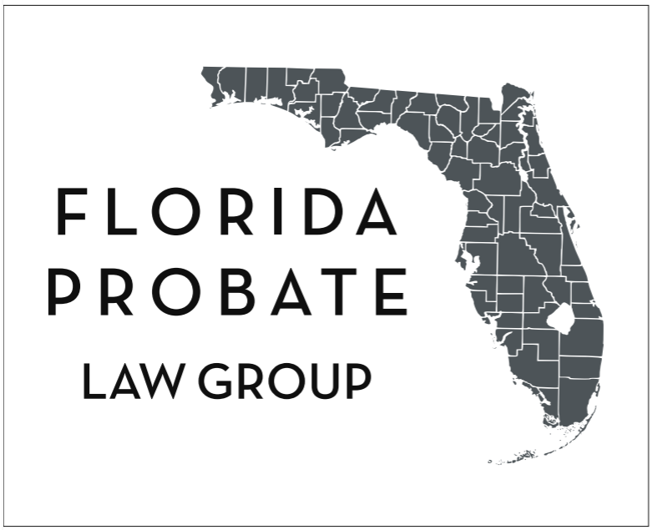
Webinars & Educational Resources: floridaprobatelawgroup.com/upcoming-webinars/
floridaprobatelawgroup.com

Digital Asset Inventory & Access Roadmap

A Practical Guide & Actionable Registry for Modern Florida Estate Plans
Important Security & Privacy Notice:
This inventory contains sensitive financial, personal, and administrative account details. NEVER record plain-text Master Passwords, PIN codes, or private crypto keys directly in an unsecured document. Instead, reference where those credentials can be securely unlocked (e.g., within a password manager, hardware security key, or encrypted digital vault). Keep this completed document stored strictly in a secure location alongside your primary estate planning instruments.

Part 1: Why a Digital Asset Inventory Is Essential
In the modern digital age, a significant portion of an individual’s financial, sentimental, and business life exists solely in electronic form. Without a clear inventory and designated fiduciary authority, critical accounts can be permanently frozen, subscription charges can drain estate funds indefinitely, sentimental family photos may be deleted by automated provider algorithms, and valuable cryptocurrency or investment assets can be lost forever.

The Florida Legal Framework: F.S. Chapter 740
Under Florida’s Uniform Fiduciary Access to Digital Assets Act (UFADAA), codified in Florida Statute Chapter 740, online service providers and custodians (e.g., Apple, Google, Microsoft, financial institutions) are legally bound by strict federal and state privacy statutes.
- The Rule of Priority: Florida law establishes a three-tiered hierarchy for governing access to digital assets upon incapacity or death:
- Custodian Online Tools: Direct designations configured within the platform itself (such as Apple Legacy Contact, Google Inactive Account Manager, or Facebook Legacy Contact) take legal precedence over all other directions.
- Estate Planning Directives: If no platform tool was utilized, the terms of a valid Florida Will, Trust, or Durable Power of Attorney explicitly granting digital asset powers under F.S. § 709.2202 and F.S. § 740.004 govern.
- Terms of Service Agreements: In the absence of an online tool or specific estate planning clause, the service provider's standard "Terms of Service" govern, which often results in immediate account deletion and a total bar to family access.
By pairing this Digital Asset Inventory with your Florida Durable Power of Attorney and Last Will, you ensure your designated "helper" (your Agent, Trustee, or Personal Representative) possesses the legal roadmap and technical coordinates needed to locate, protect, and marshal your electronic assets.

Part 2: Primary Hardware, Devices & Master Access
Before cataloging specific online services, identify the physical hardware through which your accounts and two-factor authentication (2FA) codes are accessed.
Device Type | Description / Model / Brand | Device Username / Associated Apple ID or Google Email | Device Passcode / PIN / Fingerprint Location | Location of Hardware
Primary Smartphone
Secondary Phone / Work Phone
Primary Laptop / Desktop
Tablet / iPad
External Hard Drives / USBs
Hardware 2FA Key (YubiKey, etc.)

Part 3: Where This Inventory & Master Credentials Are Stored
Indicate below how and where your trusted helper can retrieve your complete credentials, encryption keys, and master access codes upon incapacity or death:
- ☐
Password Manager (Recommended)
- Provider: ___________________________________________ (e.g., 1Password, Bitwarden, Dashlane, Apple Passwords)
- Master Account Username/Email: ___________________________________________
- Emergency Access / Master Key Location: ___________________________________________ (e.g., Emergency Sheet in home fireproof safe)
- Emergency Contact Configured within App: [ ] Yes [ ] No
- ☐
Encrypted Digital File
- File Name & Format: ___________________________________________ (e.g., VeraCrypt volume, encrypted ZIP, FileVault)
- Storage Location / Cloud URL / Drive: ___________________________________________
- Decryption Key Reference: ___________________________________________
- ☐
The Verified Vault / Digital Legal Vault
- Vault Platform / Host: ___________________________________________
- Account Identifier / PIN Reference: ___________________________________________
- Authorized Trusted Contacts: ___________________________________________
- ☐
Secure Custodian Vault / Physical Safe Deposit Box
- Bank / Depository Institution: ___________________________________________
- Safe Box # / Physical Safe Combination: ___________________________________________
- Key / Access Card Location: ___________________________________________
- Authorized Signer Listed at Bank: ___________________________________________

Part 4: Categorized Digital Asset Worksheet
Complete each applicable section below. Attach additional inventory sheets if more room is required.

Category A: Online Banking, Credit Cards & Traditional Financial Accounts
Ensure your Agent under Durable Power of Attorney possesses statutory banking authority under F.S. § 709.2208(1).
Financial Institution | Account Type (Checking, Savings, Mortgage, Credit Card) | Account Name / Last 4 Digits | Associated Email / Login ID | 2FA Method (SMS, Authenticator App, Email) | Transfer / Post-Death Instructions (POD/TOD, Close, Transfer)
1.
2.
3.
4.
5.

Category B: Investment Platforms, Brokerages & Payment Apps
Platform / Brokerage (Vanguard, Fidelity, Schwab, PayPal, Venmo, CashApp) | Account Type (Taxable Brokerage, IRA, Roth IRA, 401k, Cash App) | Account Identifier / Last 4 Digits | Associated Login ID / Email | Named Beneficiaries on File? (Yes / No / Uncertain) | Specific Instructions for Helper
1.
2.
3.
4.
5.

Category C: Cryptocurrency, Hardware Wallets & Web3 Assets
CRITICAL WARNING: Never write down your 12- or 24-word secret recovery seed phrases or private keys on an unencrypted document. Anyone who sees a seed phrase can permanently take the funds. Reference only the physical location of the backup metal plate, paper card, or hardware device.
Asset / Exchange / Wallet Type (Coinbase, Kraken, Ledger, Trezor, MetaMask) | Associated Email / Account Handle | Public Wallet Address (Optional) | Physical Location of Hardware Device (e.g., Office safe, lockbox) | Physical Location of Seed Phrase / Recovery Key (e.g., Safe box, seed plate) | Instructions (Liquidate, Transfer to Heir, Retain)
1.
2.
3.
4.

Category D: Primary Email Accounts
Email accounts are the ultimate master gateway to all other logins, password reset links, and financial notices. Controlling primary email is your helper's top priority.
Email Provider (Gmail, Yahoo, Outlook, Proton, iCloud, Custom Domain) | Full Email Address | Purpose (Primary Personal, Bills & Taxes, Old/Junk, Work) | Recovery Email / Backup Phone Configured? | Inactive Account / Legacy Setting Configured? (e.g., Google Inactive Account Manager) | Instructions (Forward emails, Archive, Delete after 90 days)
1.
2.
3.
4.

Category E: Cloud Storage, Photos & Personal Records
Preserves family photo libraries, genealogy records, tax PDF archives, and creative works.
Cloud Service (Apple iCloud, Google Drive, Dropbox, OneDrive, Amazon Photos) | Associated Username / Apple ID | Type of Content Stored (Family Photos, Tax Returns, Documents, Scans) | Platform Legacy Contact Activated? (e.g., Apple Legacy Contact Key) | Where Legacy Access Key / Proof Is Stored | Wishes (Download & Distribute Photos to Family, Erase)
1.
2.
3.
4.

Category F: Social Media & Public Profiles
Platform (Facebook, Instagram, LinkedIn, X/Twitter, YouTube, Reddit) | Account Username / Handle | Associated Email or Phone | Platform Legacy Contact Selected? (e.g., Facebook Legacy Contact) | Desired Post-Death Status (Memorialize Profile, Delete Immediately, Post Final Farewell Message) | Notes / Special Wishes
1.
2.
3.
4.

Category G: Online Businesses, Websites, Domains & Digital Intellectual Property
Essential for digital creators, ecommerce merchants, consultants, and business owners to prevent revenue interruption or domain expiration.
Asset / Service Type (GoDaddy, Shopify, WordPress, Stripe, Amazon Seller, Substack) | Domain Name / Storefront URL / Account Name | Registrar / Hosting Provider | Associated Admin Email & 2FA Setup | Monetization / Connected Payout Bank | Immediate Business Action Required (Assign Admin, Fulfill Orders, Liquidate, Sell)
1.
2.
3.
4.

Category H: Recurring Subscriptions, Utilities & Streaming Services
Listing these accounts prevents recurring credit card and bank drafts from draining estate balances after incapacity or death.
Service Name (Netflix, Amazon Prime, Spotify, Adobe, Gym, Utility Auto-Pay) | Renewal Cycle (Monthly / Annual) | Estimated Cost & Payment Method (Card, Bank draft) | Linked Email / User ID | Instructions (Cancel immediately, Transfer ownership to surviving spouse)
1.
2.
3.
4.
5.
6.

Part 5: Designated Helper & Fiduciary Contact Information
Record the trusted individuals authorized under your estate planning instruments to act on your digital assets.

1. Primary Digital Fiduciary / Helper
- Full Legal Name: __________________________________________________
- Relationship: ______________________________________________________
- Mailing Address: ___________________________________________________
- Phone Number: _____________________________________________________
- Email Address: _____________________________________________________
- Role Specified In:
[ ] Florida Durable Power of Attorney (Lifetime Incapacity)
[ ] Florida Last Will & Testament (Personal Representative)
[ ] Florida Revocable Living Trust (Successor Trustee)

2. Alternate / Successor Digital Fiduciary
- Full Legal Name: __________________________________________________
- Relationship: ______________________________________________________
- Mailing Address: ___________________________________________________
- Phone Number: _____________________________________________________
- Email Address: _____________________________________________________

Part 6: Affirmation & Annual Review Log
I have reviewed this Digital Asset Inventory to confirm that all key accounts, hardware locations, and access directives are accurate and up to date. I understand that keeping this document current is vital to protecting my estate and sparing my family unnecessary expense.
Document Owner / Principal Signature: _____________________________________________
Printed Name: ____________________________________________________________________
Date Executed: ______________________, 20

Annual Review Record
Set a recurring annual calendar reminder (e.g., during tax season or your birthday) to audit and update this list:
Review Date | Changes Made / Accounts Added or Closed | Owner Initials

